WORK BREAKDOWN STRUCTURE



NETWORK DIAGRAM

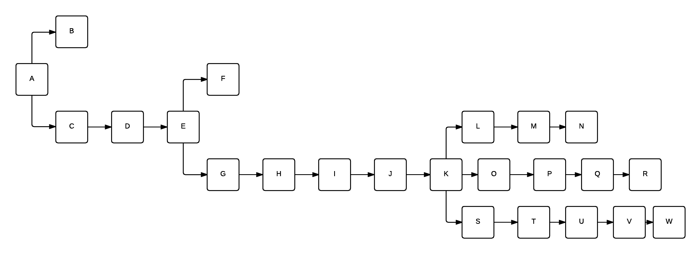













Variance = ((Pessimistic time - optimistic time)/6) ^2





Calculating the probability of completing the project in less than 109 days

Z = (Specified time – path expected time)/Path standard time



**PROJECT CRASHING TIME**



**ESTIMATION**





**Productivity**

Developer’s Experience and Capability = Nominal = 13

CASE tool = Very Low = 4

PROD = (25+4)/2 = 8.5

**Object Point Analysis**

**Screens:**

1. Register
2. Login
3. Home
4. Profile
5. Restaurants List
6. Menu
7. Cart
8. Order Accept/Reject
9. Order Received

|  |  |  |  |
| --- | --- | --- | --- |
| Name | Objects | Complexity | Weight |
| Register | Screen | Simple | 1 |
| Login | Screen | Simple | 1 |
| Home | Screen | Medium | 2 |
| Profile | Screen | Difficult | 3 |
| Restaurants List | Screen | Simple | 1 |
| Menu | Screen | Medium | 2 |
| Cart | Screen | Simple | 1 |
| Order Accept/Reject | Screen | Medium | 2 |
| Order Received | Report | Simple | 2 |
| TOTAL | | | 15 |

**Effort in Person Months**

PM = (NAP * (1 - %reuse / 100)) / PROD

Where PM is the effort in person months

NAP is the number of application points

PROD is the productivity

PM = (15 * (1 – 0/100)) / 8.5

PM = 1.76 person-months

**Function Point Estimation**

|  |  |  |  |
| --- | --- | --- | --- |
| Name | External User Types | Complexity | FP |
| Register | External Input Type | Low | 3 |
| Login | External Input Type | Low | 3 |
| Home | External Output Type | Average | 5 |
| Profile | External Input Type | High | 6 |
| Restaurants List | External Output Type | Low | 4 |
| Menu | External Output Type | Average | 5 |
| Cart | External Output Type | Low | 4 |
| Order Accept/Reject | External Inquiry Type | Average | 4 |
| Order Received | External Output Type | Low | 4 |
| TOTAL | | | 38 |

**Convert Function Points to Line OF Code (LOC)**

Estimated Size = Total Function Points * Published Figures in Java

= 38 * 53

= 2204

= 2.204 KLOC

**Scale Factors**

|  |  |  |
| --- | --- | --- |
| Scale Factor | Assessment | Value |
| Precedentedness | Low | 4.96 |
| Development Flexibility | Nominal | 3.04 |
| Architecture/Risk Resolution | Low | 5.65 |
| Team Cohesion | High | 2.19 |
| Process Maturity | High | 3.12 |
| TOTAL | | 18.96 |

**Effort Adjustment Factor**

|  |  |  |
| --- | --- | --- |
| Name | Assessment | Values |
| Required Reusability | Average | 1.0 |
| Personnel Capability | High | 0.75 |
| Personnel Experience | High | 0.70 |
| Facilities Available | High | 0.88 |
| Schedule Pressure | High | 1.0 |
| Product | | 4.33 |

**Effort = 2.45 * (0.848) ^ 1.011 * 4.33**

= 8.94 person-months